|  |  |
| --- | --- |
|  |  |

SAR in Rapid Time

# Agency record check template

This document is a SCIE tool to support use of the SAR in Rapid Time model.

See [Safeguarding Adult Reviews (SARs) In Rapid Time](https://www.scie.org.uk/safeguarding/adults/reviews/in-rapid-time) (<https://www.scie.org.uk/safeguarding/adults/reviews/in-rapid-time>) for further information.

This document has been produced by SCIE for third party use as a template. SCIE is not responsible for, and is not the publisher of, third party content which may be added to this document.

## A new SAR commissioned by [add your Board name] Safeguarding Adults Board

Following [the death/injury of xxx/add relevant details for your case], [add your Board name] Safeguarding Adults Board has decided to arrange for the conduct of a Safeguarding Adults Review (SAR). The SAR is going to be conducted using a new process to enable learning to be turned around more quickly than usual. The model is referred to as a SAR in Rapid Time.

## What is a SAR in Rapid Time?

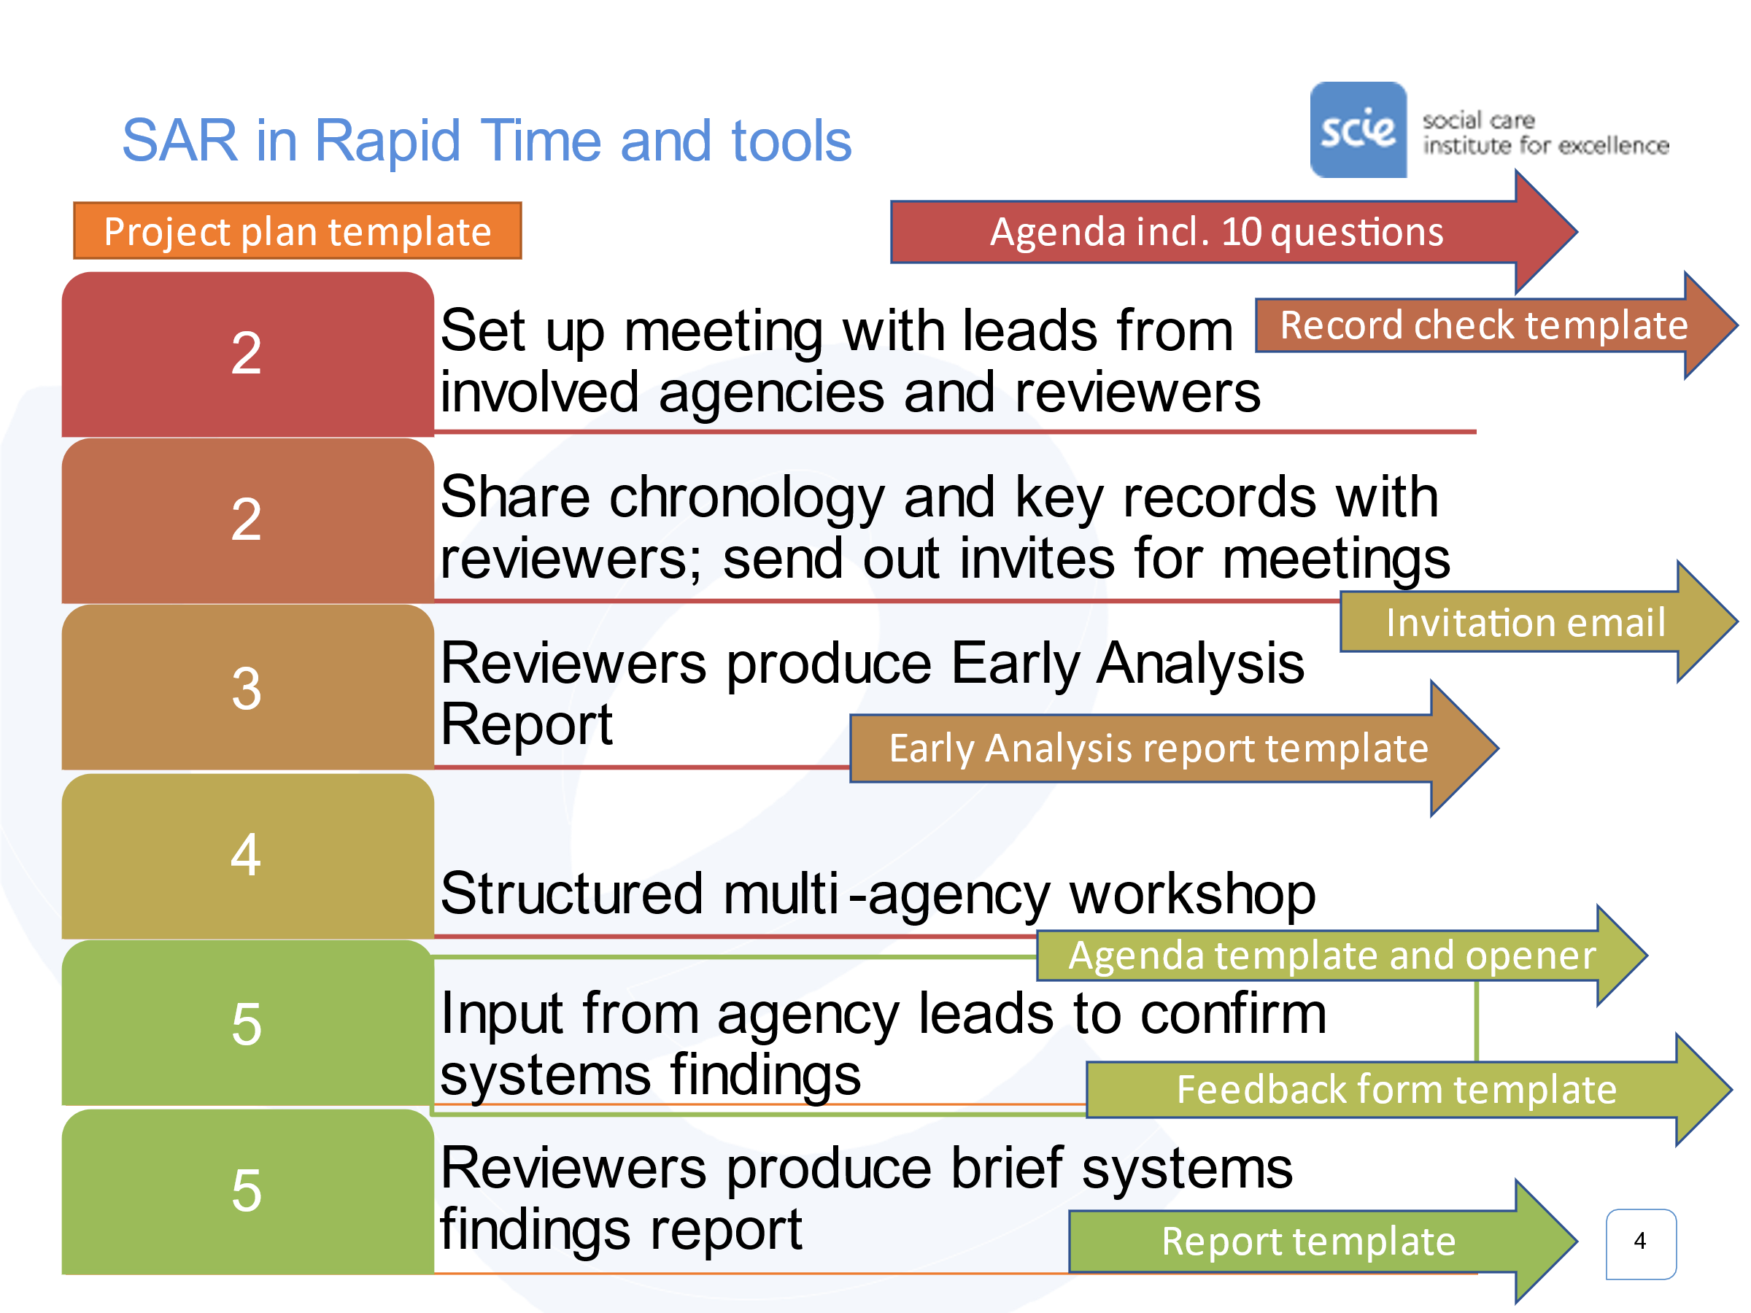A SAR in Rapid Time aims to turnaround learning anywhere from a five or six week timeframe, following the set up meeting. The set up meeting is held after the decision has been made to progress with a review. An outline of the process is captured below.

The learning produced through a SAR in Rapid Time concerns ‘systems findings’. Systems findings identify social and organisational factors that make it harder or make it easier for practitioners to do a good job day-to-day, within and between agencies.

Standardised processes and templates support an analysis of a case to identify systems findings in a speedy turnaround time. The process is supported by remote meeting facilities and does not require any face-to-face contact.

## Progress to date

The SAR in Rapid Time set up meeting was held on [insert date].

We prioritised the following wider systems issues or areas, that the SAR is being set up to illuminate:

* [cut and paste bullet list from set up meeting write up]

The time period of the case we are going to look at in order to explore these issues is: [insert dates from/to]

## What we urgently need from you

You have been identified as an agency who is known to have had, or may have had contact with the person who is the subject of this SAR in Rapid Time. In light of the focus and time period of the SAR detailed above, we need make sure we have all the basic facts about the extent and nature of agency involvement with the person and any family members. We need enough detail that we can invite the right practitioners and/or team leads to the multi-agency meeting that will be an important part of this SAR in Rapid Time. Given the tight turnaround of the SAR in Rapid Time we also want to know your agency reflections at this stage about strengths and weaknesses in practice, and the causes of those.

We are initially asking agencies to:

* Check your agency’s records to see if you have had contact with the person, their family members or close associates listed.
* Complete the brief chronology template below.
* Provide a brief appraisal of practice.
* Keep your agency’s submission in relation to this case separate from the case records/files.

If you have already submitted a record check as part of the SAB’s early consideration of this case, please review your earlier submission in light of the set up meeting specification of the timeframe to be reviewed, and the wider systems areas that we want to better understand through this SAR in Rapid Time. If you previously shared any analysis, please resubmit this using the format provided in section (6) below.

We are aiming to complete the review within [insert number] working days. Time is of the essence, so we are grateful for the priority that you can give this.

Please return this document to the Business Unit before [insert date/time].

### Advice and submission of this form

|  |
| --- |
| If you have any questions or queries about the completion of the chronology template please contact the SAB Business Unit:  Name:  Phone:  Email: |
| Please submit completed form before [insert date/time]:  Secure email address: |

## Initial information sharing – single agency input

### Your details

|  |  |
| --- | --- |
| **Name of agency** |  |
| **Name and job title of person completing the chronology** |  |
| **Contact details (address, phone, email)** |  |
| **Date of submission** |  |
| **Adult who is the subject of the review** |  |
| **Dates to be covered by the chronology** |  |

### Declaration of contact

|  |  |
| --- | --- |
| **Has the agency named above had contact with the adult (or family or close associates) listed in section 1 of this form?** | Yes/No |
| **If you have answered No, you do not need to complete further sections and should return the form to the SAB Business Manager** [insert email address]  **If you have answered Yes, please complete the remainder of section 1 of this form.** | |

### Agency information for the time period under review (narrative summary)

|  |
| --- |
| Please summarise in a paragraph or two, how your agency has been involved with the person(s) subject of this SAR during the time period under review. Give a brief description of the nature and frequency of your involvement. |
|  |

### Historical context of agency information (narrative summary)

|  |
| --- |
| If your agency had involvement with the person **before** the period under review, please summarise it here, in a paragraph or two. |
|  |

### Agency information for the time period under review (brief chronology)

|  |
| --- |
| Please show the sequence of your agency’s involvement over the time period under review, using the table below.  **Please do not anonymise this chronology**. Identify family members and staff, including job titles. Anonymisation will be done centrally. |
|  |

| **Your agency** | **Date (from)** | **Date (to)** | **Description of agency activity/contact/communication:**  **Please detail names and roles of key staff involved in the entry** | **Comment or questions about the appropriateness and quality of activity/response** |
| --- | --- | --- | --- | --- |
|  |  |  |  |  |
|  |  |  |  |  |
|  |  |  |  |  |
|  |  |  |  |  |
|  |  |  |  |  |
|  |  |  |  |  |
|  |  |  |  |  |
|  |  |  |  |  |
|  |  |  |  |  |
|  |  |  |  |  |
|  |  |  |  |  |
|  |  |  |  |  |
|  |  |  |  |  |
|  |  |  |  |  |
|  |  |  |  |  |

### Summary of reflections on your agency’s practice

|  |  |
| --- | --- |
| Please provide **an overall view on what was good and where there were problems**, in the agency activity reviewed, highlighting any key issues (RCA - care and service delivery problems, incl. contributory factors). |  |
| Please identify **any areas for concern as to the way in which partners have worked together** to safeguard the subject/s. and contributory factors. |  |
| What are **the main wider systems issues that were at play** in this case? What are the underlying causes that need to be tackled to enable improved practice in the future? |  |
| **Any other issues, factors or information to note?** |  |

### Anything else

|  |
| --- |
| Please include any further relevant information that you wish to bring to the attention of the SAR in Rapid Time meeting or issues you would like to see discussed at this meeting. |
|  |

|  |
| --- |
| Please submit completed form to:  Secure email address: |

**Thank you**

Social Care Institute for Excellence

Isosceles Head Office, One High Street

Egham TW20 9HJ

