|  |  |
| --- | --- |
|  |  |

SAR in Rapid Time

# Systems Findings Report template

This document is a SCIE tool to support use of the SAR in Rapid Time model.

See [Safeguarding Adult Reviews (SARs) In Rapid Time](https://www.scie.org.uk/safeguarding/adults/reviews/in-rapid-time) (<https://www.scie.org.uk/safeguarding/adults/reviews/in-rapid-time>) for further information.

This document has been produced by SCIE for third party use as a template. SCIE is not responsible for, and is not the publisher of, third party content which may be added to this document.

## A new SAR commissioned by [add your Board name] Safeguarding Adults Board

Following [the death/injury of xxx/add relevant details for your case], [add your Board name] Safeguarding Adults Board has decided to arrange for the conduct of a Safeguarding Adults Review (SAR). The SAR is going to be conducted using a new process to enable learning to be turned around more quickly than usual. The model is referred to as a SAR in Rapid Time.

## What is a SAR in Rapid Time?

A SAR in Rapid Time aims to turnaround learning anywhere from a five or six week timeframe, following the Set Up meeting. The Set Up meeting is held after the decision has been made to progress with a review. An outline of the process is captured below

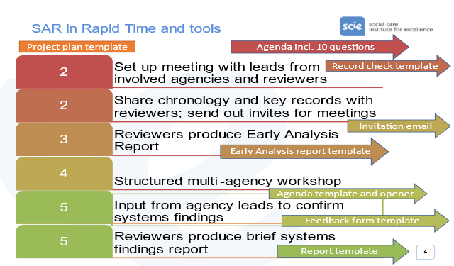

The learning produced through a SAR in Rapid Time concerns ‘systems findings’. Systems findings identify social and organisational factors that make it harder or make it easier for practitioners to do a good job day-to-day, within and between agencies.

Standardised processes and templates support an analysis of a case to identify systems findings in a speedy turnaround time. The process is supported by remote meeting facilities and does not require any face-to-face contact.

## This document

This document forms the final output of the SAR in Rapid Time. It provides the systems findings that have been identified through the process of the SAR. These findings are future oriented. They focus on social and organisational factors that will make it harder or easier to help someone in circumstances such as [insert name], in a timely and effective manner. As such, they are potentially relevant to professional networks more widely.

In order to facilitate the sharing of this wider learning the case specific analysis is not included in this systems findings report. Similarly, an overview of the methodology and process is available separately.

Each systems finding is first described. Then a short number of questions are posed to aid SABs and partners in deciding appropriate responses.

### Contact

|  |
| --- |
| If you have any questions or queries about the completion of the chronology template please contact the SAB Business Unit:  Name:  Phone:  Email: |
| Please submit completed form before [insert date/time] to:  Secure email address: |

## Systems findings

What are the key barriers/enablers we have learnt about that make it harder/easier for good practice to flourish and that need to be tackled in order to see improvements?

The SAR in Rapid Time methodology distinguishes between the case findings, and systems findings. Systems findings are the underlying issues that helped or hindered in the case and are systemic rather than one-off issues. Each finding attempts to describe the systems finding barrier or enabler and the problems it creates. This requires that we think beyond [insert name] to the wider organisational and cultural factors. It also requires that we refrain at this stage from exploring solutions or articulating what is needed, to specify first what the current reality of barriers/enablers is, that the SAR process has helped us understand.

**Finding 1. [Add descriptive sentence capturing the systems issue that needs addressing]**

### Systems finding

[(a) capture the systems issue in generic terms, i.e. what a safe set up looks like/what is needed to support good, timely work by professionals; b) reflect on what this SAR led you to see of the state of the systems issue locally; c) give brief illustration from the case.]

### Questions for the SAB and partners

* [add questions to prompt SAB and partners as they think about what actions would be helpful, and how this systems finding fits with improvement work ongoing or forthcoming]

**Finding 2. [Add descriptive sentence capturing the systems issue that needs addressing]**

### Systems finding

[(a) capture the systems issue in generic terms, i.e. what a safe set up looks like/what is needed to support good, timely work by professionals; b) reflect on what this SAR led you to see of the state of the systems issue locally; c) give brief illustration from the case.]

### Questions for the SAB and partners

* [add questions to prompt SAB and partners as they think about what actions would be helpful, and how this systems finding fits with improvement work ongoing or forthcoming]

**Finding 3. [Add descriptive sentence capturing the systems issue that needs addressing]**

### Systems finding

[(a) capture the systems issue in generic terms, i.e. what a safe set up looks like/what is needed to support good, timely work by professionals; b) reflect on what this SAR led you to see of the state of the systems issue locally; c) give brief illustration from the case.]

### Questions for the SAB and partners

* [add questions to prompt SAB and partners as they think about what actions would be helpful, and how this systems finding fits with improvement work ongoing or forthcoming]

**Finding 4. [Add descriptive sentence capturing the systems issue that needs addressing]**

### Systems finding

[(a) capture the systems issue in generic terms, i.e. what a safe set up looks like/what is needed to support good, timely work by professionals; b) reflect on what this SAR led you to see of the state of the systems issue locally; c) give brief illustration from the case.]

### Questions for the SAB and partners

* [add questions to prompt SAB and partners as they think about what actions would be helpful, and how this systems finding fits with improvement work on-going or forthcoming]

Social Care Institute for Excellence

Isosceles Head Office, One High Street

Egham TW20 9HJ

