|  |  |
| --- | --- |
|  |  |

SAR in Rapid Time

# Set Up Meeting briefing

This document is a SCIE tool to support use of the SAR in Rapid Time model.

See [Safeguarding Adult Reviews (SARs) In Rapid Time](https://www.scie.org.uk/safeguarding/adults/reviews/in-rapid-time) (<https://www.scie.org.uk/safeguarding/adults/reviews/in-rapid-time>) for further information.

This document has been produced by SCIE for third party use as a template. SCIE is not responsible for, and is not the publisher of, third party content which may be added to this document.

## A new SAR commissioned by [add your Board name] Safeguarding Adults Board

Following [the death/injury of xxx/add relevant details for your case], [add your Board name] Safeguarding Adults Board has decided to arrange for the conduct of a Safeguarding Adults Review (SAR). The SAR is going to be conducted using a new process to enable learning to be turned around more quickly than usual. The model is referred to as a SAR in Rapid Time.

## What is a SAR In Rapid Time?

A SAR in Rapid Time aims to turnaround learning anywhere from a five or six week timeframe, following the Set Up Meeting. The Set Up Meeting is held after the decision has been made to progress with a review. An outline of the process is captured below.

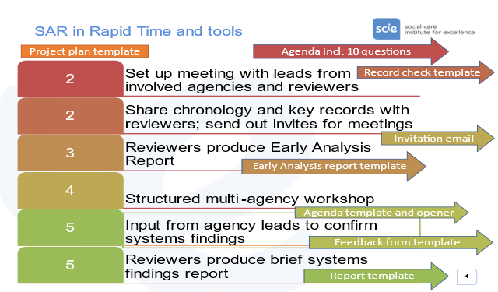

The learning produced through a SAR in Rapid Time concerns ‘systems findings’. Systems findings identify social and organisational factors that make it harder or make it easier for practitioners to do a good job day-to-day, within and between agencies.

Standardised processes and templates support an analysis of a case to identify systems findings in a speedy turnaround time. The process is supported by remote meeting facilities and does not require any face-to-face contact.

## Set Up Meeting – the purpose

Below are 10 questions to structure discussions to set up a SAR in Rapid Time.

|  |
| --- |
| Set Up Meeting - 10 questionsBrief summary of the caseWhy is there an urgency to identifying and sharing learning from this case?What are the wider systems issues or areas that we want to learn about?Do these issues require direct participation of front-line practitioners in the review process and/or strategic leads of relevant agencies/sectors?What time period of the case do we need to look at to explore these issues?Which agencies/individuals need to participate?What further information needs to be gathered from the relevant agencies?What vulnerabilities, sensitivities and/or tensions are there for individuals and agencies around this case?Do we know who needs to be informed from the person, their representatives, advocates or family members? What options can we offer them for contributing to the SAR in Rapid Time?Agreeing timescales, actions and next steps. |

These questions emphasise transparency of rationale for prioritising speed over more thoroughness or depth to the review (Q2) as well as emphasising clarity from the outset, as to the wider systems issues or areas that the review is being set up to illuminate (Q3).

Question 3 supports a strategic approach to commissioning. What are the practice areas or issues the case appears to give you the opportunity to explore in more depth? Does your wider intelligence and performance data indicate local learning needs in any of those areas? Are there any areas you can rule out of scope for the SAR, because you are likely to duplicate learning already identified about what is helping and what is getting in the way of good practice? The aim of discussions in relation to Question 3 is to stop your SAR being reactive only, with the focus of the SAR determined only to the specifics of the case. The aim is to allow strategic consideration and increase the chance of generating organisational learning in areas where it is needed.

The remaining questions cover all the pragmatic decisions needed in order for the project plan to be finalised, meetings dates set and invites sent, and documentary evidence from all relevant agencies to be sought. They make sure reviewers are versed of existing sensitivities that need to be managed carefully as people are brought together (Q8). They confirm when and how the person (where it is possible) and family members, will be invited to contribute (Q9).

## Set Up Meeting – participants

Having the right people participate in the Set Up Meeting is an important mechanism for gaining buy-in to the SAR and its focus. The SAB Chair, Business Manager and SAR Subgroup Chair alone may be able to answer all of the questions, but this would omit having all relevant agencies involved from the start and so building cross-agency agreement about the learning that you are striving to gain from the case. For these reasons, SCIE suggests that participants in the SAR in Rapid Time Set Up Meeting include:

* SAB Chair
* SAR Business Manager
* SAR Subgroup Chair or equivalent who lead original consideration of the case for a SAR
* Heads of Service or equivalent from all agencies who were involve in the case and likely to be involved in the SAR. These may be the same people who were involved in SAR Subgroup discussions. However, there may be other agencies who do not sit on the SAR Subgroup who also need to be involved

Social Care Institute for Excellence

Isosceles Head Office, One High Street

Egham TW20 9HJ

